**Global Air Transportation**

1. **Introduce**

**1.1Overview**

This Global Air Transportation Network dataset is a comprehensive collection of information on airports, airlines, and their routes. It contains information such as names, cities, countries, code (IATA and ICAO) longitudes, latitudes and altitudes of airport across the world with detailed time zone and daylight saving time data. Additionally, this includes information about airlines including their IDs, name aliases, IATA and ICAO codes, call signs country of origin and active\inactive status.

**1.2Purpose**

The business requirement of the Global Air Transportation Network- Airports, Airlines, and Routes dataset us to provide stakeholders in the aviation industry with accurate, up-to date information on the worldwide air transportation network. This information can be used to optimize routes, improve operational efficiency, and enhance customer experience.

This can contribute to the development of air transportation networks that are more efficient, safe, and environmentally sustainable.

1. **Problem definition and Design thinking**

2.1Empathy map 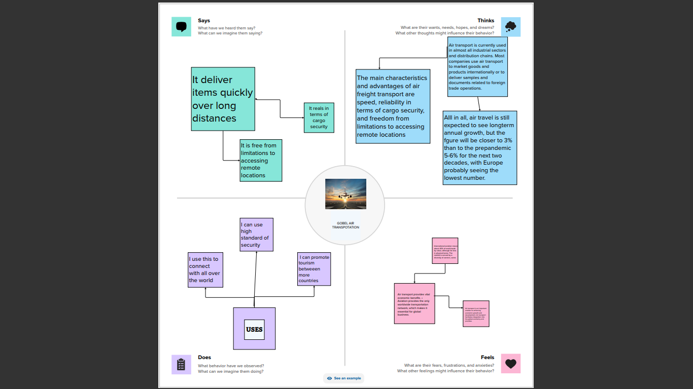

2.2ideation and brainstorming

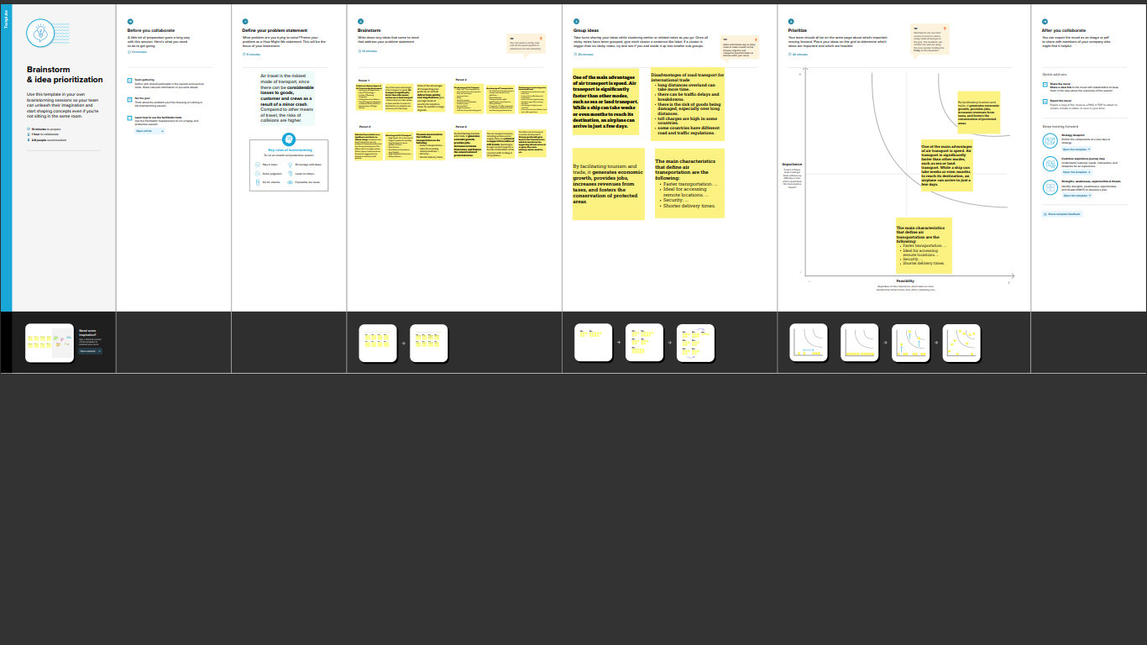

1. **Result**

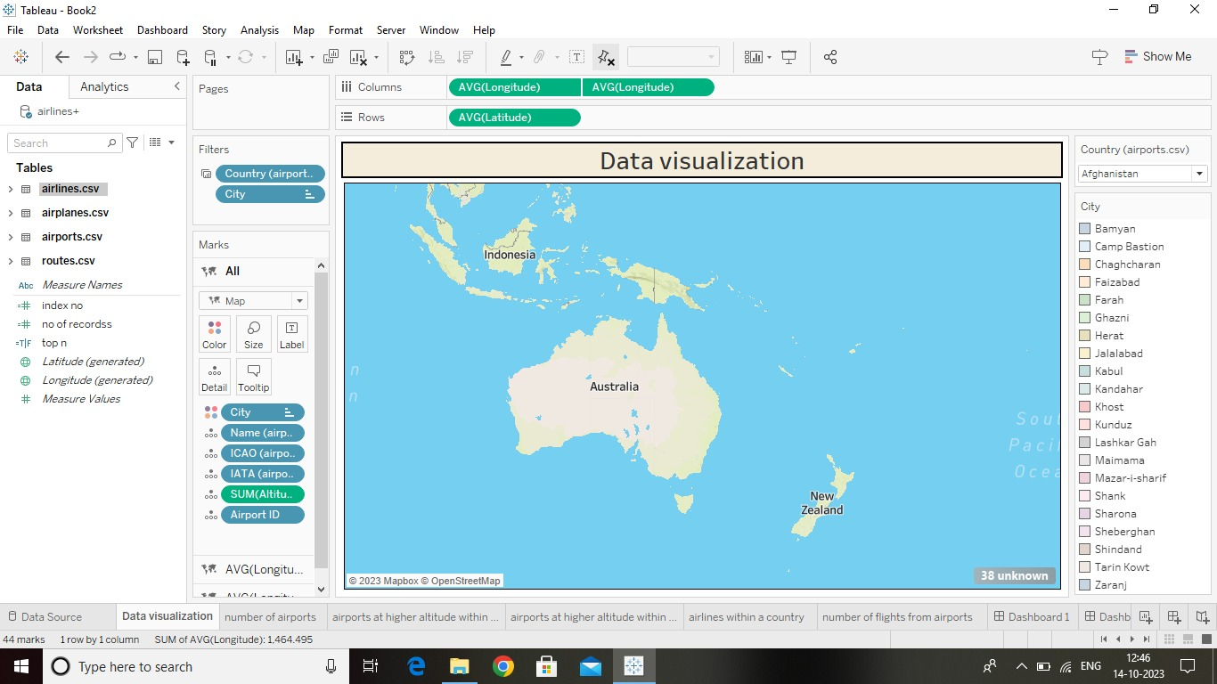 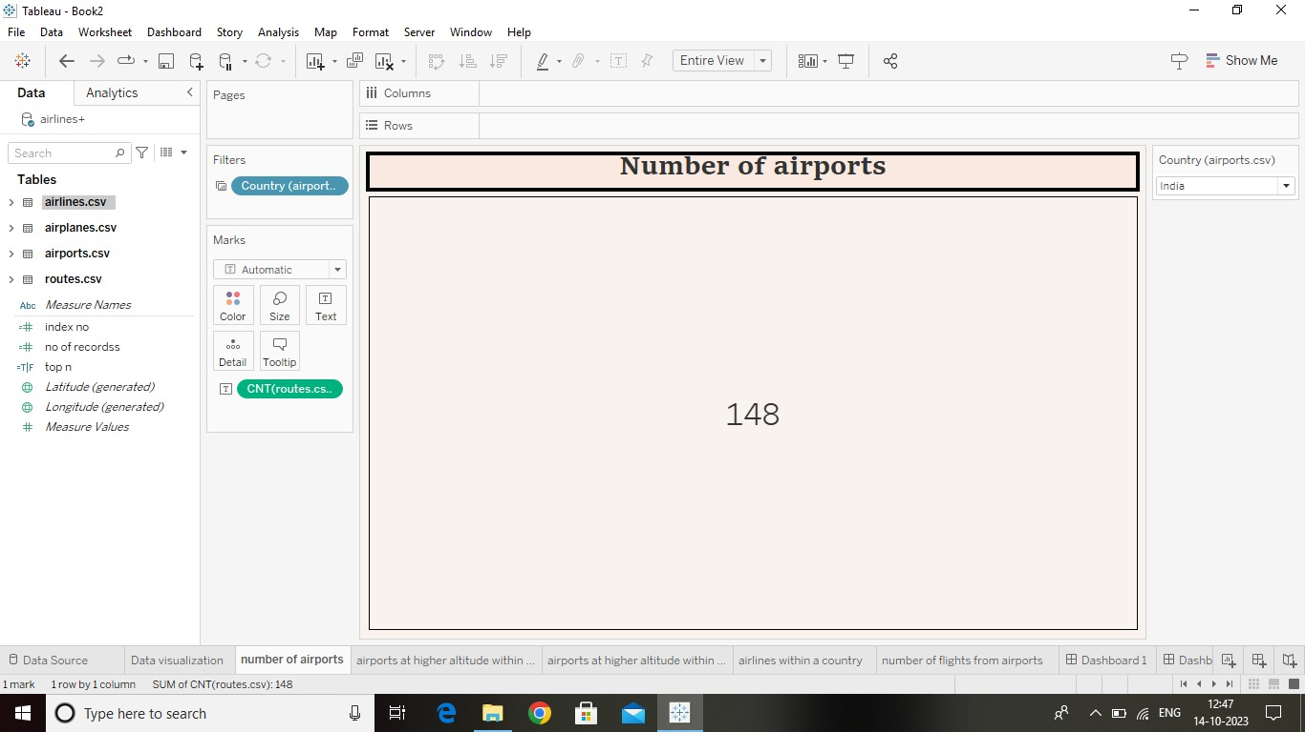 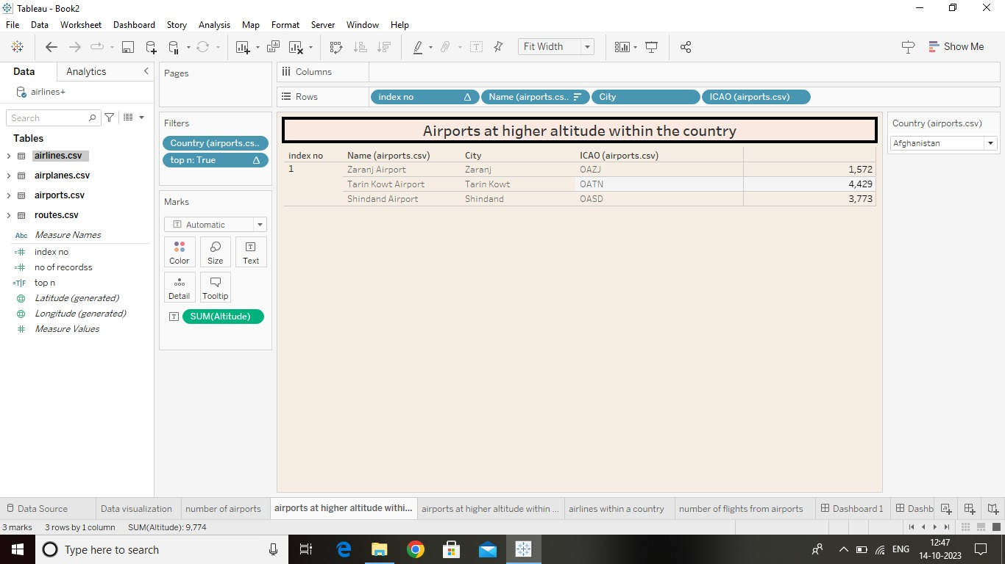 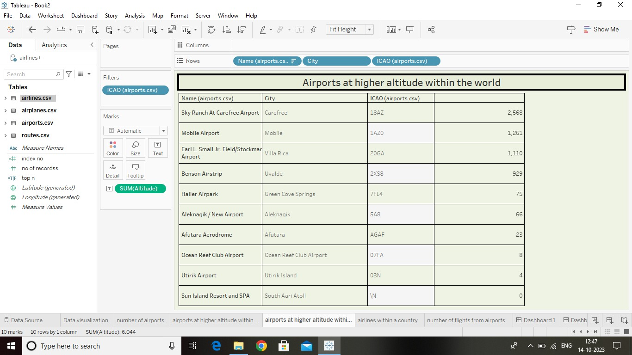 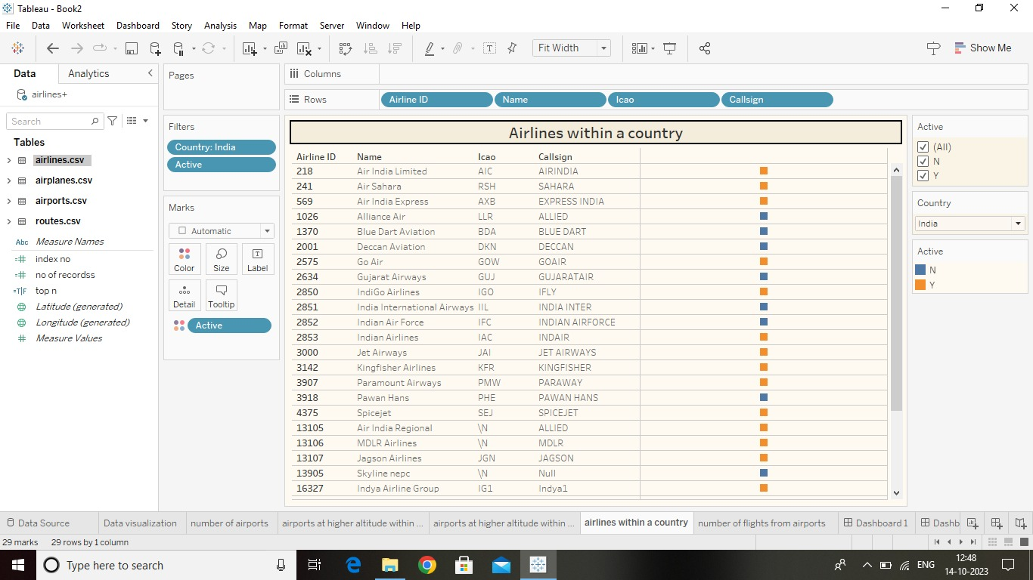 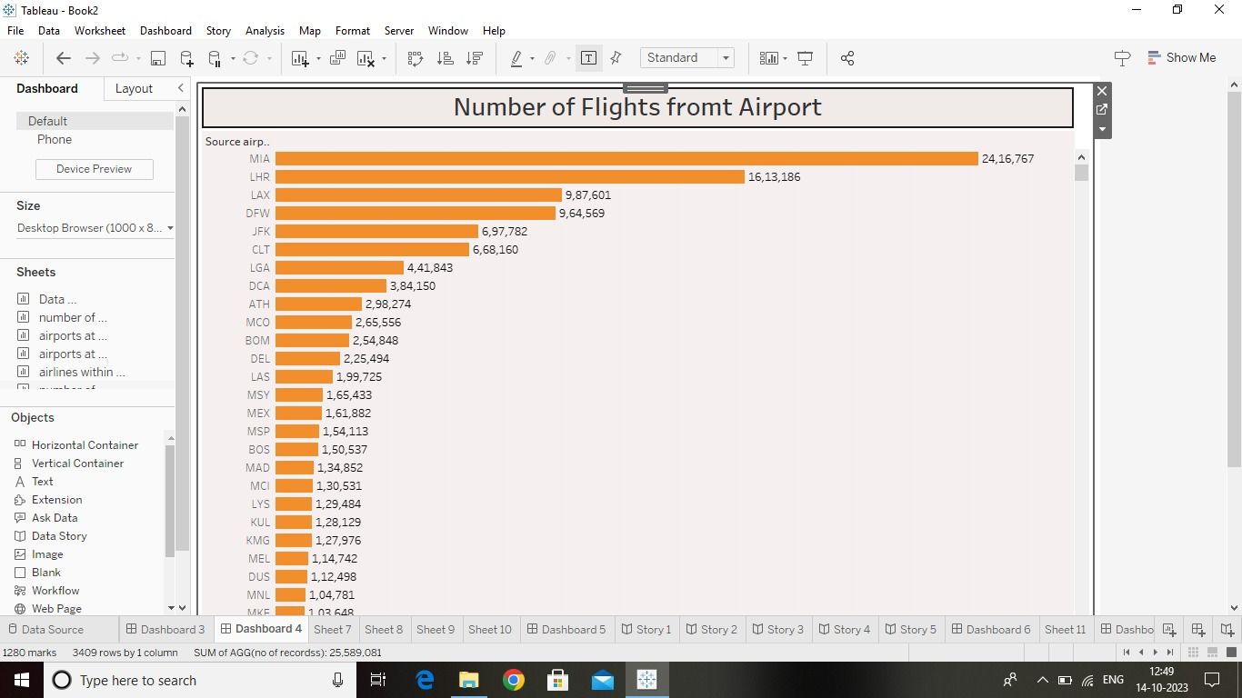 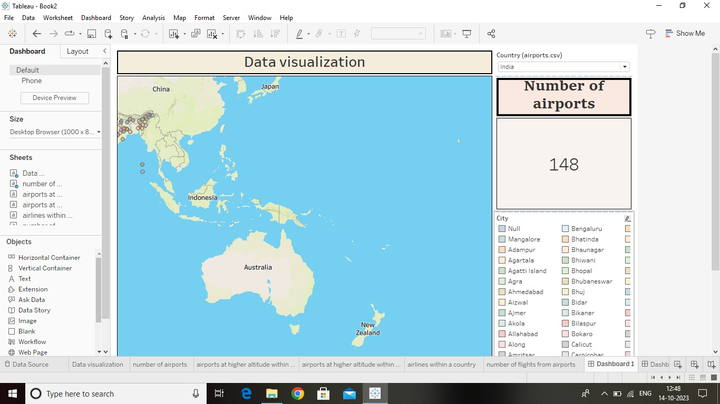 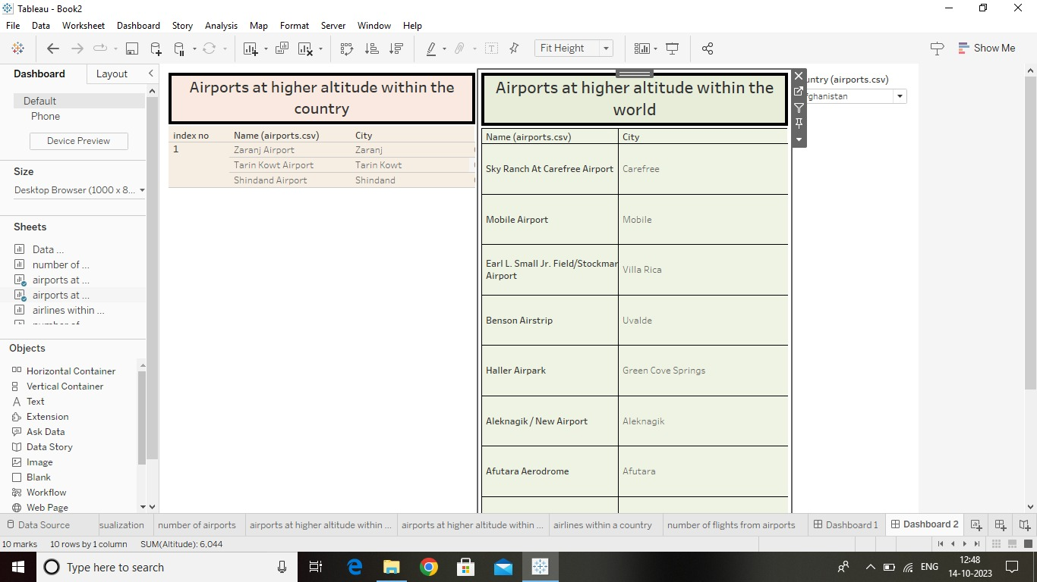 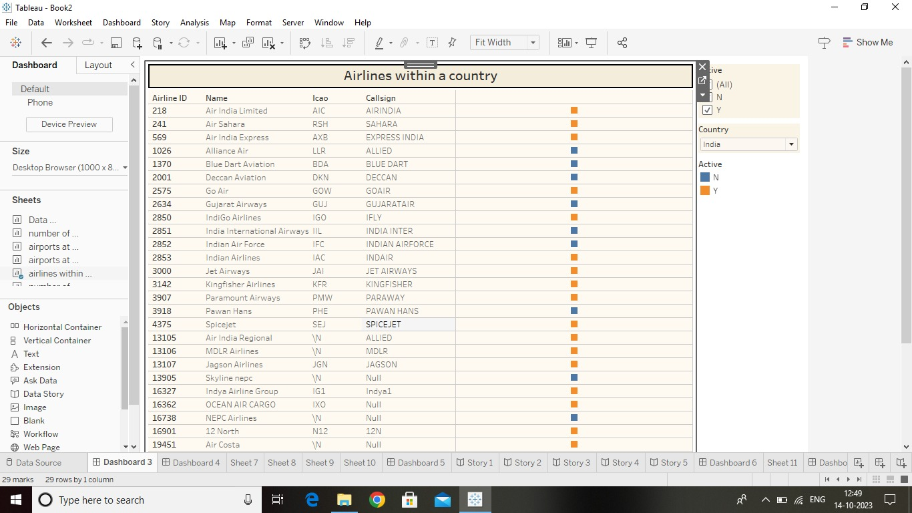  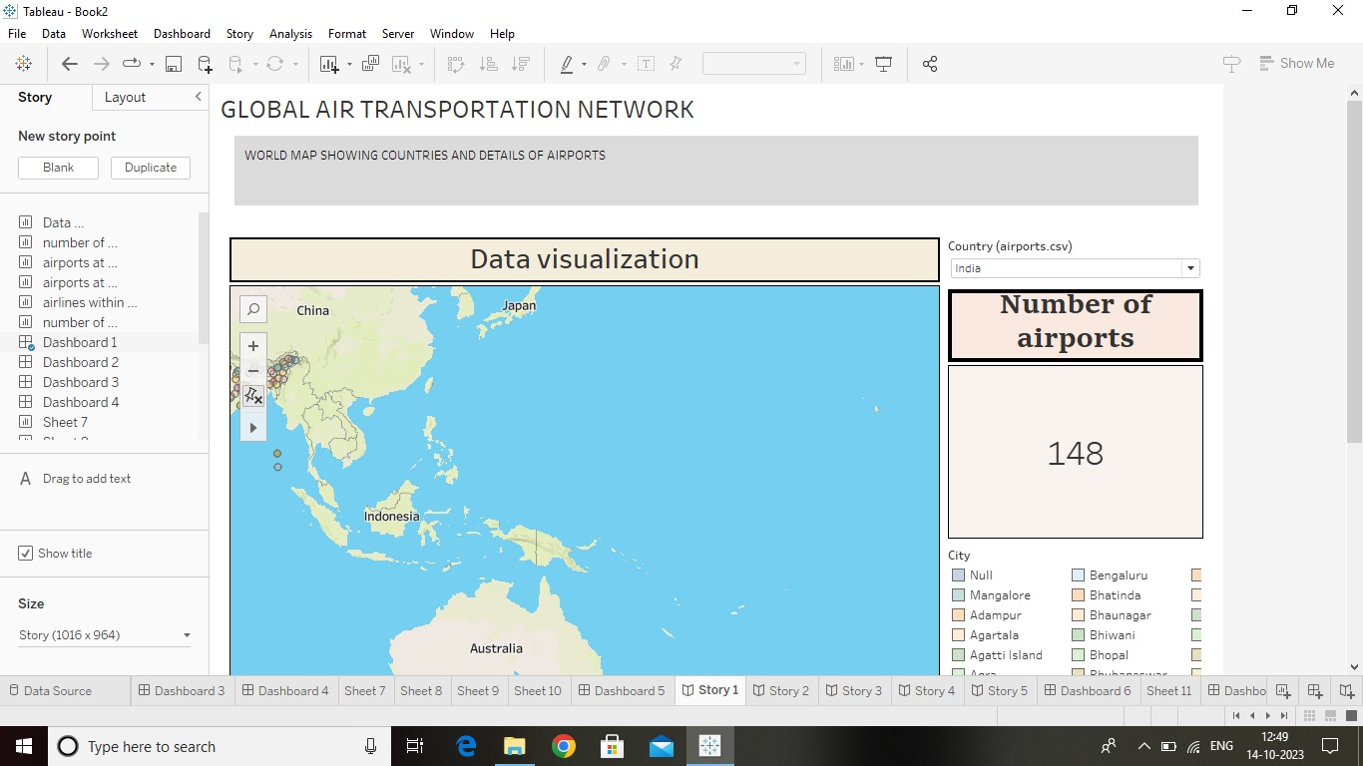

dfeeeeee

1. **Advantages and Disadvantages**

**Advantages:**

* It is the fastest mode of transport.
* It is eco-friendly.
* It is the cheapest mode of travel.
* It is beneficial during emergencies.

**Disadvantage:**

* Air transport can involve higher costs than other options
* Limited Capacity
* Restriction on Hazardous Goods.

1. **Application**

They help to determine weaknesses of the system in case of various kinds of disruption. Once weaknesses are determined, a substitute node which can support all or part of the traffic load can be identified through the alternative strength for the pair.

1. **Conclusion**

In conclusion, Air Transport has played a part in fostering these developments, but airlines, and to a greater degree, air transport infrastructure has had to respond to changing demands for its services. Air transport is facilitator and, as such, the demand for its service is derived from the requirements for high quality, speedy and reliable international transport.

1. **Future scope**

The industry has a number of domestic and international airlines, as well as large network of airports. The future of the industry in India is likely to see continued growth and expansion, driven by factors such as a growing middle class, increased tourism, and government policies supporting the industry.